“Let’s Make a Difference Together”
St. Paul Lutheran Church

158 Fish Hill Road
PO Box 196
Tannersville, Pennsylvania 18372
Telephone: (570) 629-1992
Fax: (570) 629-2038
Website: www.stpaultannersvillepa.org

Pastor’s Email: PastorWoody80@gmail.com
Pastor’s Cell Phone: 484-338-4340
Parish Administrator’s Email: parishadmin@stpaultannersvillepa.org

Worship Services: Sunday at 9:00 A.M.
Holy Communion: 1st & 3rd Sundays of each month & Festivals
Christian Education: Sunday’s at 10:15 A.M.
Air Conditioned & Handicapped Accessible
Welcome to St. Paul Lutheran Church

OUR MISSION STATEMENT: Grounded in faith and growing in grace, we share the Good News of Jesus Christ by word and deed in our local community and throughout the world.

Are you visiting St. Paul? Are you interested in membership or just looking to see if St. Paul is a good fit for you and/or your family?
Please call (570-629-1992) or stop by our office during regular business hours (Monday – Thursday 9:00am – 1:00pm) and speak to our Parish Administrator, Leanna Wickline, who will be happy to guide you through the membership process and help you find information on all of the great programs at St. Paul Lutheran Church.
SILENT MEDITATION. . . Please note – the silent meditation is a part of the morning worship service. This is a time for individual reflection; a time for communicating with God, as well as a time of preparation for the service of worship. We encourage you to use it in a meaningful way.

Please respect the prayerful atmosphere of this holy place. We ask that you turn off all cell phones and electronic devices. Thank you.

Our Church Staff
Pastor: Reverend Rashion “Woody” Santiago
Parish Administrator: Mrs. Leanna D. Wickline
Choir Director/Organist: Mr. Robert Jones

2022 Council Members

Grant Allen
Dawn Bartron
Bill Below
Chris Kinsley Sr.
Nicole Kresge
Carl Reindl
Deb Storman
Beth Werkheiser
Leanna Wickline

Website: www.stpaultannersvillepa.org
Facebook: www.facebook.com/stpaultannersvillepa
YouTube: https://www.youtube.com/channel/UCsvvR6Fl09zcaiDPY174k5A

Worship Service
Eleventh Sunday After Pentecost
Sunday, August 21, 2022

Words in bold print denote congregational response.

Call to Worship (Chimes)

Announcements

Prelude

*Greeting
Creator God. Because you make all that draws forth our praise and the forms in which to express it,
We praise you.
Because you make artists of us all, awakening courage to look again at what is taken for granted, grace to share these insights with others, vision to reveal the future already in being,
We praise you.
Because you form your Word among us, and in your great work embrace all human experience, even death itself, inspiring our resurrection song,
We praise you. Yours is the Glory. Amen.

*Confession
When you molded creation in the beginning, God of righteousness, you named all that you made “good.” Yet we have chosen repeatedly to see your world and others in it and call them “bad,” “less than,” “not good enough.” We have not realized the depths of your love for us and so we have tried to keep you to ourselves instead of sharing the gifts that are yours.
We have let others go hungry.
Forgive us.
We have let people sleep under bridges and in their cars.
Forgive us.
We have suggested that health is a luxury rather than a basic human right.
Forgive us.
We have taken the resources of the land as though tomorrow and our children don’t matter.
Forgive us.
We have waged wars when others didn’t see things our way or when we wanted their land.
Forgive us.
We have traumatized soldiers by asking them to do unthinkable things.
Forgive us.
We have not listened to those brutalized by others who have power over them.
Forgive us.
We have not carried out our responsibilities as citizens to work for the good of all persons.
Forgive us.
We have walked away or shut out persons we deemed different from ourselves.
Forgive us.
We have not spoken up in situations where racism and sexism were rampant.
Forgive us.
We have not been quiet and listened as someone tried to explain their feelings to us.
Forgive us.
We have not encouraged all persons to reach their fullest potential as your children.
Forgive us.
O God, this list makes us ill and we know it only touches the surface of our brokenness. It seams that we have taken your good creation and made it a mess. Yet you appear repeatedly with reminders of forgiveness, mercy and grace. Even as we consider all the wrongs in the world, you call us again to work with you to right these wrongs – to share our food, to provide shelter and health care, to mediation and reconciliation, to listening and to speaking up. Yet it is clear, God of justice, that none of this brokenness can be mended without our acceptance of your forgiveness and fresh start.
Wash us and your world clean, God, with your healing forgiveness.
Redirect our energies and our actions.
We give ourselves to you for healing and sending. In the name of Jesus. Amen.

*Absolution
God forgave these grave sins on the cross centuries ago and forgives them again today. Go and, with Jesus, do what you can for God’s goodness in the world and walk in the ways of Jesus Christ. We are forgiven!
Amen

*Sharing of the Peace
The peace of Christ be with you always.
And also with you.
Share a sign of peace with one another.
Please stay in your pew area and show a sign of peace and greeting with one another.

*Hymn

*Kyrie

*Hymn of Praise

*Prayer of the Day (Lector)
Let us pray.
A brief silence is kept before the prayer.
O God, mighty and immortal, you know that as fragile creatures surrounded by great dangers, we cannot by ourselves stand upright. Give us strength of mind and body, so that even when we suffer because of human sin, we may rise victorious through your Son, Jesus Christ, our Savior and Lord.
Amen.

First Reading: Isaiah 58:9b-14

God promises those who have returned from exile that where justice and mercy prevail, the ruins will be rebuilt and light will rise in the darkness. It is a day for new beginnings.

^{9b}If you remove the yoke from among you, the pointing of the finger, the speaking of evil, ¹⁰if you offer your food to the hungry and satisfy the needs of the afflicted, then your light shall rise in the darkness and your gloom be like the noonday. ¹¹The Lord will guide you continually, and satisfy your needs in parched places, and make your bones strong; and you shall be like a watered garden, like a spring of water, whose waters never fail. ¹²Your ancient ruins shall be rebuilt; you shall raise up the foundations of many generations; you shall be called the repairer of the breach, the restorer of streets to live in.
¹³If you refrain from trampling the sabbath, from pursuing your own interests on my holy day; if you call the sabbath a delight and the holy day of the Lord honorable; if you honor it, not going your own ways, serving your own interests, or pursuing your own affairs; ¹⁴then you shall take delight in the Lord, and I will make you ride upon the heights of the earth; I will feed you with the heritage of your ancestor Jacob, for the mouth of the Lord has spoken.

The word of the Lord.
Thanks be to God.

Psalm: Psalm 103:1-8
¹Bless the Lord, O my soul, and all that is within me, bless God’s holy name.
²Bless the Lord, O my soul, and forget not all God’s benefits—
³who forgives all your sins and heals all your diseases;
⁴who redeems your life from the grave and crowns you with steadfast love and mercy;
⁵who satisfies your desires with good things so that your youth is renewed like an eagle’s.
⁶O Lord, you provide vindication and justice for all who are oppressed.
⁷You made known your ways to Moses and your works to the children of Israel.
⁸Lord, you are full of compassion and mercy, slow to anger and abounding in steadfast love.

Second Reading: Hebrews 12:18-29

Using images of Moses, the writer presents a striking vision of the new covenant of God made possible in Christ. There is no longer fear; only awe in the new promise in Christ into which we are invited.

¹⁸You have not come to something that can be touched, a blazing fire, and darkness, and gloom, and a tempest, ¹⁹and the sound of a trumpet, and a voice whose words made the hearers beg that not another word be spoken to them. ²⁰(For they could not endure the order that was given, “If even an animal touches the mountain, it shall be stoned to death.” ²¹Indeed, so terrifying was the sight that Moses said, “I tremble with fear.”) ²²But you have come to Mount Zion and to the city of the living God, the heavenly Jerusalem, and to innumerable angels in festal gathering, ²³and to the assembly of the firstborn who are enrolled in heaven, and to God the judge of all, and to the spirits of the righteous made perfect, ²⁴and to Jesus, the mediator of a new covenant, and to the sprinkled blood that speaks a better word than the blood of Abel.
²⁵See that you do not refuse the one who is speaking; for if they did not escape when they refused the one who warned them on earth, how much less will we escape if we reject the one who warns from heaven! ²⁶At that time his voice shook the earth; but now he has promised, “Yet once more I will shake not only the earth but also the heaven.” ²⁷This phrase, “Yet once more,” indicates the removal of what is shaken—that is, created things—so that what cannot be shaken may remain. ²⁸Therefore, since we are receiving a kingdom that cannot be shaken, let us give thanks, by which we offer to God an acceptable worship with reverence and awe; ²⁹for indeed our God is a consuming fire.

The word of the Lord.
Thanks be to God.
Please stand for the Gospel. (Lector)

*Gospel Acclamation

*Gospel: Luke 13:10-17

The holy gospel according to Luke, the 13th chapter.
Glory to you, O Lord.

¹⁰Now [Jesus] was teaching in one of the synagogues on the sabbath. ¹¹And just then there appeared a woman with a spirit that had crippled her for eighteen years. She was bent over and was quite unable to stand up straight. ¹²When Jesus saw her, he called her over and said, “Woman, you are set free from your ailment.” ¹³When he laid his hands on her, immediately she stood up straight and began praising God. ¹⁴But the leader of the synagogue, indignant because Jesus had cured on the sabbath, kept saying to the crowd, “There are six days on which work ought to be done; come on those days and be cured, and not on the sabbath day.” ¹⁵But the Lord answered him and said, “You hypocrites! Does not each of you on the sabbath untie his ox or his donkey from the manger, and lead it away to give it water? ¹⁶And ought not this woman, a daughter of Abraham whom Satan bound for eighteen long years, be set free from this bondage on the sabbath day?” ¹⁷When he said this, all his opponents were put to shame; and the entire crowd was rejoicing at all the wonderful things that he was doing.

“The gospel of the Lord.”
Praise to you, O Christ.

Sermon
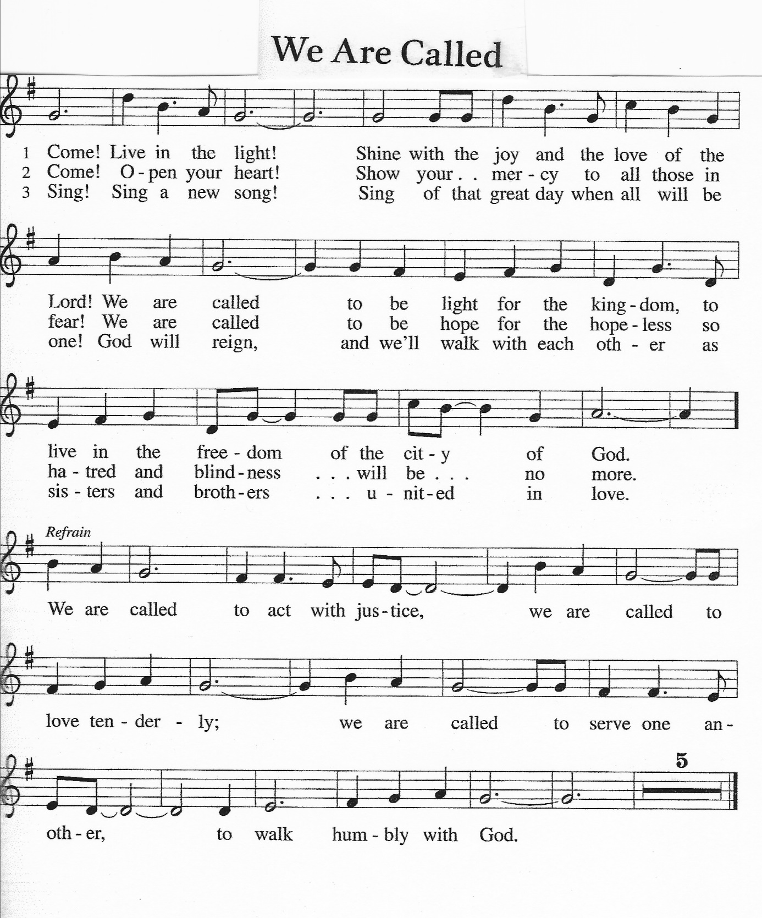
*Hymn of the Day

*The Nicene Creed
We believe in one God, the Father, the Almighty, maker of heaven and earth, of all that is, seen and unseen.
We believe in one Lord, Jesus Christ, the only Son of God, eternally begotten of the Father, God from God, Light from Light, true God from true God, begotten, not made, of one Being with the Father; through him all things were made. For us and for our salvation he came down from heaven, was incarnate of the Holy Spirit and the virgin Mary and became truly human. For our sake he was crucified under Pontius Pilate; he suffered death and was buried. On the third day he rose again in accordance with the scriptures; he ascended into heaven and is seated at the right hand of the Father. He will come again in glory to judge the living and the dead, and his kingdom will have no end.
We believe in the Holy Spirit, the Lord, the giver of life, who proceeds from the Father and the Son,* who with the Father and the Son is worshiped and glorified, who has spoken through the prophets. We believe in one holy catholic and apostolic church. We acknowledge one baptism for the forgiveness of sins. We look for the resurrection of the dead, and the life of the world to come. Amen.

Prayers of the People (Lector)
Trusting in God’s extraordinary love, let us come near to the Holy One in prayer.
A brief silence.
You crown your church with steadfast love and mercy. Guide us continually in our baptismal covenant to strive for justice and peace in all the earth. Use our diverse gifts in service to the whole people of God. Merciful God,
receive our prayer.
You satisfy the needs of all creatures. Protect the habitats of fish and birds. Repair ecosystems damaged by misuse, neglect, or natural disaster, that all creation may thrive. Merciful God,
receive our prayer.
You make your ways known to all people. Inspire the rulers and leaders of nations with your compassion and mercy. Raise up activists and community organizers to restore places affected by violence, poverty, and inequality. Merciful God,
receive our prayer.
You provide justice for all who are oppressed and relief to all who are afflicted. Heal those who are bent over by addiction, depression, and anxiety. Set free all who cry out under the weight of mental, emotional, or physical distress. Merciful God,
receive our prayer.
You call us to delight in the sabbath. Renew our bodies, minds, and spirits in this worshiping assembly. Give rest to all who lead our congregation in worship, study, and service. Merciful God,
receive our prayer.
Generations bless your holy name. We give you thanks for the communion of saints who have gathered in prayer and praise in this place. Support us in your love until we rest forever in you. Merciful God,
receive our prayer.
At this time, you are welcomed to offer your prayer concerns and joys, either aloud or silently. Pause. Receive the prayers of your children, merciful God, and hold us forever in your steadfast love; through Jesus Christ, our holy Wisdom.
Amen.

Offering Prayer
God of abundance:
you have set before us a plentiful harvest. As we feast on your goodness, strengthen us to labor in your field, and equip us to bear fruit for the good of all, in the name of Jesus. Amen.

*The Great Thanksgiving
The Lord be with you.
And also with you.
Lift up your hearts.
We lift them to the Lord.
Let us give tanks to the Lord our God.
It is right to give him thanks and praise.

*Proper Preface
It is indeed right and salutary that we should at all times and in all places offer thanks and praise to you, O Lord, holy Father, through Christ our Lord; who on this day overcame death and the grave, and by his glorious resurrection opened to us the way of everlasting life. And so, with the Church on earth and the hosts of heaven, we praise your name and join their unending hymn:

*Prayer of Thanksgiving
God of our ancestors, friend in our midst, your children come before you.
Here is food! Here is drink!
These things are yours before they are ours.
Now we are making a feast, but it is a thanksgiving:
God, we are thanking you.
With our ancestors in faith and all the hosts of heaven,
O God, we thank you and rejoice.
This food—we shall eat it in your honor!
This drink—we shall drink it in your honor!
We thank you for giving us life.
We thank you!
We thank you for giving us freedom.
We thank you!
We thank you for bringing us peace.
We thank you!
We thank you for the one who bore our sins upon the cross.
We thank you!
We thank you for the one who brought us over from death to life.
We thank you!
Father, send the Spirit of life,
the Spirit of power and fruitfulness.
With the Spirit’s breath, speak your Word into these things.
Give us who eat and drink the living body and the lifeblood of Jesus, our brother,
life and power and fruitfulness of heart and body.
Give us true communion with your Son.

*Words of Institution
On the night of his suffering,
he gave thanks for the bread that he held in his hands.
This bread he shared among his followers, saying:
All of you, take this, eat this;
it is my body, handed over for you.
Do this and remember me.
The body of Christ! Amen
Then he shared drink with them, saying:
All of you, take this, drink this;
it is my blood, the blood of the new covenant
that begins now and lasts forever.
This blood is poured out for you and for all people
so that sins may be taken away.
Do this and remember me.
The blood of Christ!
Amen.
Lord's Prayer
Gathered into one by the Holy Spirit, let us pray as Jesus taught us.
Our Father, who art in heaven, hallowed be thy name, thy kingdom come, thy will be done, on earth as it is in heaven. Give us this day our daily bread; and forgive us our trespasses, as we forgive those who trespass against us; and lead us not into temptation, but deliver us from evil. For thine is the kingdom, and the power, and the glory, forever and ever. Amen.

Invitation to the Table
In Christ’s presence there is fullness of joy. Come to the banquet.

Communion
The body of Christ given for you.
The blood of Christ shed for you.
Hymn During Communion

*Prayer after Communion
Life-giving God, through this meal you have bandaged our wounds and fed us with your mercy. Now send us forth to live for others, both friend and stranger, that all may come to know your love. This we pray in the name of Jesus.
Amen.

*Blessing
The God of peace, Father, ☩ Son, and Holy Spirit, bless you, comfort you, and show you the path of life this day and always.
Amen.

*Closing Hymn

*Choral Benediction
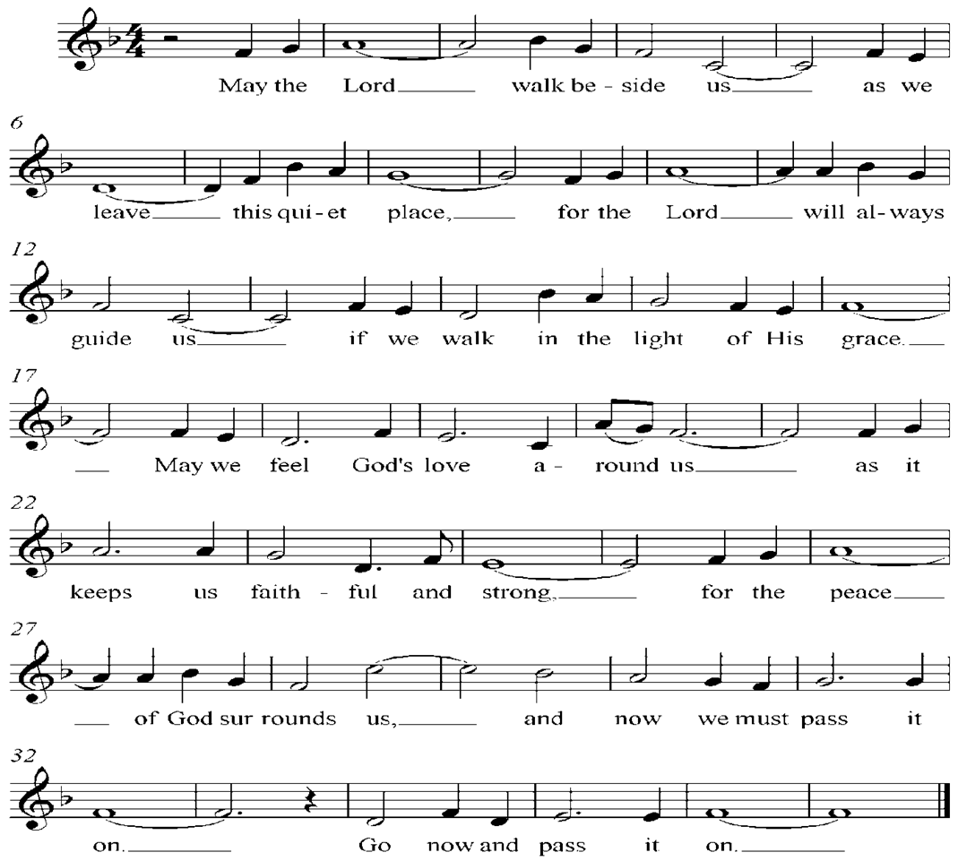

*Charge to the People
Beloved in the Lord, God has shown you what is good. What does the Lord require of you but to do justice, and to love kindness, and to walk humbly with your God?
Amen.

Postlude

"The worship ends. . .the service begins."

Copyright © 2022 Augsburg Fortress. All rights reserved. Reprinted by permission under Augsburg Fortress Liturgies Annual License #SAS017969.
New Revised Standard Version Bible, Copyright © 1989, Division of Christian Education of the National Council of the Churches of Christ in the United States of America. Used by permission. All rights reserved.
Revised Common Lectionary, Copyright © 1992 Consultation on Common Texts, admin Augsburg Fortress. Used by permission.

Prayers have been requested for the following brothers and sisters in Christ who have concerns needing God’s help…

Sharen Ace; Sr. Msgt. William F. Allen; Specialist William “Blake” Allen; Tom Altemose; Mark Anthony; Evelyn Arroyo; Daniel Bartron; the Below family at the passing of Wynne Below; Diane Berner; Dillon Berenti; Major Matthew Blessing; David Brong; Judi Carman; Elaine Cornelus; the family of John DeVivo at his passing; Sue Felker; Jamie Fisher & family in the loss of her son Elijah Johnson; Paul Frantz; Todd & Anna Geil; LilliAnna Daniels; Renee Depuy; Doris Drury; John Drury; Louis Genset; Lynn Gerber; the family of Chris Haley Jr.; Susie Herzberg; Harrison Herzberg; Matt Herzberg; Charlie Hemple; T. J. Imhof; Carol Jones; Ian Juica; Robbie Kinsley; Nikolaos Kotretsos; Eleanor Kreuger; Dawne Ladeas; Joeann Lance; Esther Laurito; David Leith; James Meckes; Steven Moore; the family of Suzanne Neumann at her passing; Steve Oberman; Dr. Kenny Pearson; Annabelle Peechatka; Anna Rivera; Jean Ross; Gloria Russell and family at the passing of Jack Russell; Claudette Segear; Vaughn Sensinger; Phyllis Sensinger; Phyllis Sherwood and family at the passing of her husband Brian; Shirley Singer; Samuel Smith, Jr.; the family of Alan K. Strand at his passing; Kamia Taylor; Greg Theadford; Jim Tomedi; Alice Weaver; Harry Weaver; Jacob Wilson; John Woodling; Carolyn Zacharias; Charles Zuccarelli; Fran Zuccarelli; for the people of Ukraine; for all who are traveling; for all of those struggling with addictions; the members of the Armed Forces of the United States; for the families and victims of the mass shootings, for all those around the world and here at home suffering from the coronavirus pandemic.

Have your prayers been answered? Or do you still need God’s help? Please let us know. Thank you to everyone who prays with us for those in need.

Thank you to all who have helped to support St. Paul’s Strunk Food Pantry! Your commitment to help is a true blessing to those who are struggling to feed their families. The pantry is always in need of basic food supplies, and we need your continued support to keep this program going strong. Items of particular need are: boxed cereal, peanut butter, canned fruit, canned potatoes, and canned meats like tuna, chicken, beef and other protein sources. Our Food Pantry remains open, although it is functioning as a curb-side service.

Inside Out Church – Wednesday at 6:30pm dinner included!
Join us each Wednesday evening for a delicious meal full of fellowship and then an in-depth discussion of a scripture passage led by Pastor Woody. The discussion reveals a deeper understanding of the scriptures and how it can guide us through our lives and grow our spiritual being.

God’s Work. Our Hands.
We will be doing two projects in September for “God’s Work. Our Hands.” The first project benefits the Foster Children in KidsPeace. We will be collecting new and used luggage, suitcases, duffle bags, etc. Many of these children, when they leave the KidsPeace hospital or residential care programs to go into foster care, they have to use garbage bags to carry their things. This program provides an alternative, letting them know that their possessions, and by extension, they are not garbage. St John’s Church in Stroudsburg has been asked to join us in this project.
The second project benefits PATH. We will be collecting needed cleaning products. Products such as paper towels, garbage bags, dish soap, Brillo pads, disinfectant wipes spray cleaners, and toilet bowl cleaner. Think of what you use to clean your home. There is a complete list of items on the handouts on the round table in the narthex. Please bring your donations to the Narthex area. All donations will be taken to PATH at one time.

Pocono Township Community Day
Saturday, September 10th is Pocono Township Community Day. St Paul will have a table with crafts for kids to do, bubbles to be handed out and we are looking for friendly people to greet our guests. We also hope to include a computer presentation that will include some highlights of our congregation including music, pictures of our facilities and events.

